Technological Dynamics in Direct Air Capture: A Statistical Analysis of Actors, Technologies, and Potential Contributions to CO₂-Separation
Frederik Schmidt, f.schmidt.1@campus.tu-berlin.de
Björn Steigerwald, TU Berlin and DIW Berlin, bs@wip.tu-berlin.de
Christian von Hirschhausen, TU Berlin and DIW Berlin, cvh@wip.tu-berlin.de

Overview
Today, the collection of carbon plays an increasing role in the debate about climate change mitigation especially in future energy production. In recent years, fundamental research in carbon capture and storage (CCTS) technologies was particularly dynamic especially in direct air capture technologies (Renfrew, Starr, and Strasser 2020; Breyer et al. 2019). It is seen as a large-scale solution in many energy and climate scenarios, including those of the International Panel for Climate Change (IPCC)(Huppmann et al. 2019; Byers et al. 2022). However, in reality many of the pilot projects have provided heterogenous results, and challenges remain to scale these small pilots to large scale CCTS(Herold, Rüster, and Hirschhausen 2010; von Hirschhausen, Herold, and Oei 2012). This paper looks at over 100 of these pilot projects, and attempts a classification in terms of R&D dynamics, size, and other technical characteristics. This is useful to asses the potential of DAC, and also to establish the link to potential downstream activities, e.g. the use of CO₂.

Methods
We have collected a unique dataset on 104 pilot projects in Direct Air Capture (DAC) and potential application (Direct Air capture Coalition 2024), as well as data on the remaining gap for rolling out these technology at scale. We perform a technological assessment and a statistical analysis in respect to technologies, application, companies and financial indicators.

Results
Detailed analysis of the data reveals a heterogenous picture (see figures) compared to predicted usage in IPCC – Scenarios. In terms of the regional distribution, the US leads the pack by far, with 37 projects, of which 10 are operational (Canada: 14 project, 2 operational, England: 9 projects, 2 operational) (Figure 1). In terms of technologies, low temperature regeneration (46 projects) is outpacing electrochemical regeneration (17) and high-temperature regeneration (15). The average size of the capture project is small. Until 2018, total capacities were negligible (below 1 Mt separated CO2), but it increasing rapidly since. In particular, from 2023 (7.4 Mt), total capacities increased to 44 Mt. The Technological Readiness Levels (TRL) are very heterogenous, the available data hints at average values of 4-6.
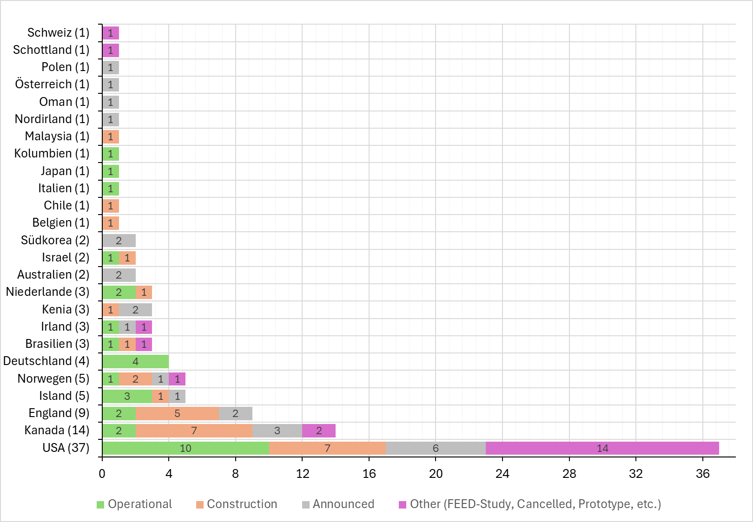
Figure 1: Distribution of DACV Projects and its Status (worldwide)
Source: Own depiction based on (Direct Air capture Coalition 2024)
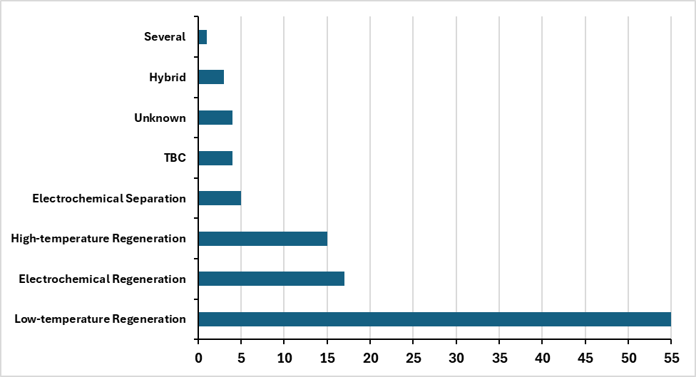
Figure 1: Distribution of identified Projects and its Technologies (worldwide)

Source: Own Depiction, based on (Direct Air capture Coalition 2024)

Conclusions
DAC is undergoing an impressive dynamic with respect to pilot projects. This is manly fundamental and some applied research on demonstrators. However, the step towards large-scale commercialization is yet to occur: 29 technologies are commercially available, but their impact on CO2-separation is still small. Further research should focus on these dynamics, i.e. from demonstration to large-scale diffusion.

References
Breyer, Christian, Mahdi Fasihi, Cyril Bajamundi, and Felix Creutzig. 2019. ‘Direct Air Capture of CO2: A Key Technology for Ambitious Climate Change Mitigation’. Joule 3 (9): 2053–57. https://doi.org/10.1016/j.joule.2019.08.010.
Byers, Edward, Volker Krey, Elmar Kriegler, Keywan Riahi, Roberto Schaeffer, Jarmo Kikstra, Robin Lamboll, et al. 2022. ‘AR6 Scenarios Database’. Zenodo. https://doi.org/10.5281/zenodo.5886912.
Direct Aircapture Coalition. 2024. ‘DAC Depoyments’. Website. https://daccoalition.org/global-dac-deployments/.
Herold, Johannes, Sophia Rüster, and Christian von Hirschhausen. 2010. ‘Vertical Integration and Market Structure along the Extended Value Added Chain Including Carbon Capture, Transport and Sequestration (CCTS)’. Project No 213744. Project Report for the European Commission SECURE Work Package 5.3.2. Dresden, Germany: Chair of Energy Economics and Public Sector Management, Dresden University of Technology.
Hirschhausen, Christian von, Johannes Herold, and Pao-Yu Oei. 2012. ‘How a “Low Carbon” Innovation Can Fail–Tales from a “Lost Decade” for Carbon Capture, Transport, and Sequestration (CCTS)’. Economics of Energy & Environmental Policy 1 (2). https://doi.org/10.5547/2160-5890.1.2.8.
Huppmann, Daniel, Elmar Kriegler, Volker Krey, Keywan Riahi, Joeri Rogelj, Katherine Calvin, Florian Humpenoeder, et al. 2019. ‘IAMC 1.5°C Scenario Explorer and Data Hosted by IIASA’. Zenodo. https://doi.org/10.5281/zenodo.3363345.
Renfrew, Sara E., David E. Starr, and Peter Strasser. 2020. ‘Electrochemical Approaches toward CO2 Capture and Concentration’. ACS Catalysis 10 (21): 13058–74. https://doi.org/10.1021/acscatal.0c03639.

