*Energy and society*

*e.g. acceptance and behavioural aspects of energy efficiency measures*

*and demand response, value of energy security, etc.*

**Title:**

**“Public knowledge and public acceptance of nuclear energy in the Baltic States compared to other EU states.”**

Keywords:

Nuclear Energy, Social Acceptance, Baltic States, Energy Policy, Public Meaning.

1. **Objectives/ scope**

This paper analyses the evolution of public attitudes and acceptance of nuclear energy in the Baltic States from 2009 to 2024, a period marked by deep geopolitical and technical changes. From this concrete example, it reflects on the significant problem in communicating complex issues related to energy and its infrastructure, energy policies and plans, and technological solutions to the public for education. It considers more particularly the role of scientists in this process, as, on the issue of nuclear energy, the public trusts scientists more than journalists, industry representatives or politicians.

The study compares data on knowledge about nuclear energy issues in the Baltic States to similar data in other states of the European Union.

1. **Methods**

The research utilized a combination of methods, including case studies of specific events and policies, analysis within socio-political and economic frameworks, data from Eurobarometer and other survey sources, reports from industry associations, rhetorical analysis of state leader’s statements, and a review of theoretical literature to examine public acceptance of nuclear energy in the Baltic States. The scope of the study spans the period from 2009 to 2024.

1. **Results, Observations, conclusions**

The study shows increasingly positive attitudes toward nuclear energy, though the Baltic states do not produce nuclear energy.

Moreover, public acceptance has increased more rapidly since 2022, following the conflict in Ukraine. Until recently, public attitudes were still strongly influenced by the negative legacy of the Chernobyl and Fukushima disasters. However, the energy crisis following the closure of the Ignalina Nuclear Power Plant in Lithuania, required for the accession to the EU, has contributed to a shift toward greater acceptance of nuclear energy.

Preliminary results indicate significant differences in acceptance levels in Baltic States – with Estonia showing the highest support for new nuclear initiatives, while Latvia and Lithuania remains more sceptical.

The survey data also reveals that there is still a significant part of society in the Baltic States without opinion, or knowledge about nuclear energy. Indeed, in the Baltic States (10-13%) of people have no opinion on the effect of nuclear energy as energy production, when the EU average is 6%. For example, in Hungary 1%, in the Czech Republic 2%, in the Netherlands and Luxembourg 3%, and in the EU the record holder in nuclear energy production and export, France, - 4%, as well as in Sweden and Slovenia.

This observation interrogates the information provided to the Baltic population. In particular, it suggests more active and interactive dissemination of scientific and technical knowledge, in a way that is easier for the public to understand, leading to a deeper understanding of scientific topics.

Technical information about nuclear energy is not widespread in the Baltic states, as they do not currently produce nuclear energy anymore, following the EU request to close the Ignalina Nuclear Power plant in Lithuania. However, the construction of small modular reactors in the Baltic States is currently on the political agenda therefore it seems relevant to increase public information about this issue.

Finally, the transition to green energy and the EUs climate targets have influenced public acceptance of nuclear energy. In this respect, the issue of nuclear waste’s environmental impact remains a critical challenge.

1. **How this paper will present novel or additive information (..) benefit to a practicing engineer**

This research can provide valuable insights for planners of future engineering education, enabling them to identify trends in nuclear energy education, including the knowledge and workforce demands of the future. The study provides a recommendation - a new method for informing the public and monitoring opinions, using the principle of an e-Learning platform. Additionally, investors can utilize these insights to assess the market potential of the nuclear energy sector in the Baltic States.

**References**

1. S.FANG, A.M.JAFFE, T.LOCH-TEMZELIDES, C.L..PRETE. “Electricity grids and geopolitics: A game-theoretic analysis of the synchronization of the Baltic States’ electricity networks with Continental Europe”, <https://doi.org/10.1016/j.enpol.2024.114068>
2. Azagra-Caro, J. M. and Pavone, V. (2024). The effect of scientific impact on science communication through art from the lens of deviance theories JCOM 23(06), A02. <https://doi.org/10.22323/2.23060202>
3. H.CHEN, X.YAO, P.SUBEIDI, C.HAO, “Residual-INR: Communication Efficient On-Device Learning Using Implicit Neural Representation”, AUGUST, 2024., DOI: 10.48550/arXiv.2408.05617
4. Orduna-Malea, C.I.Font-Julian, “Research on Research Visibility”, February 2025., DOI: 10.48550/arXiv.2502.11923
5. Energy process modeling tool : [https://exchange.iseesystems.com/public/andra/nekp02062021/index.html#page2](https://exchange.iseesystems.com/public/andra/nekp02062021/index.html" \l "page2)
6. Eurostat: https://ec.europa.eu/eurostat/statistics-explained/index.php?title=Nuclear_energy_statistics
7. Eurobarametr: , <https://europa.eu/eurobarometer/surveys/detail/3227>
8. Statista: https://www.statista.com/topics/1087/nuclear-power/#topicOverview
9. European Commission, *Commission opens in-depth State aid investigation into Belgian support for lifetime extension of two nuclear reactors*, Business, Economy, Euro., 22 July 2024, Europa.eu
10. European Commission, *EU taxonomy for sustainable activities*, finance.ec.europa.eu
11. Official Journal of the European Union, *COMMISSION DELEGATED REGULATION (EU) 2022/1214,* Document 32022R1214, EUR-Lex., 9 March 2022, eur-lex.europa.eu
12. European Commission, *In focus: EU nuclear energy policy – why it matters to us all*, Energy, 13 March 2024, energy.ec.europa.eu
13. European Parliament, *Strategic autonomy and the future of nuclear energy in the EU*, Briefing , February 2024, www.europarl.europa.eu
14. Brugidou M., Bouillet J., *A return to grace for nuclear power in European public opinion? Some elements of a rapid paradigm shift,* Fondation Robert Schuman, Schuman Papers n°662, 27 March 2023
15. Zepa I., *From energy islands to energy highlands?* Political barriers to sustainability transitions in the Baltic region, Energy Research & Social Science, Volme 93, November 2022, https://doi.org/10.1016/j.erss.2022.102809
16. The OECD Nuclear Energy Agency (NEA), Organisation for economic co-operation and development, report on *Public Attitudes to Nuclear Power*, NEA Nr. 6859, OECD Publications, France, 2010, ISBN 978-92-64-99111-8
17. European Nuclear Society, Support for nuclear energy is increasing in all EU member states, 2022, [www.euronuclear.org](http://www.euronuclear.org)

*Towards climate neutrality*: *Economic impacts, opportunities and risks*, Monograph, University of Latvia Press, 2023, 272 pages, 9.pp., ISBN 978-9934-18-947-0, https://doi.org/10.22364/tcn.23

1. Younghwan K., Minki K., Wonjoon K. *Effect of the Fukushima nuclear disaster on global public acceptance of nuclear energy,* Energy Policy,Volume 61, October 2013, pages 822-828,<https://doi.org/10.1016/j.enpol.2013.06.107>
2. Latré E., Perko T., Thijssen P., *Public opinion change after the Fukushima nuclear accident: The role of national context revisited*, Energy Policy,Volume 104, May 2017, pages 124-133, <https://doi.org/10.1016/j.enpol.2017.01.027>
3. International Atomic Energy Agency: [25 Feb 2025] <https://www.iaea.org/newscenter/news/iaea-profile-a-womans-mission-to-advance-nuclear-information-management>
4. Exploring Energy Demand Dynamics, ENERDAY 2024. Book of Abstracts: <https://tu-dresden.de/bu/wirtschaft/bwl/ee2/ressourcen/dateien/tagungen/enerday/enerday-2024/BoA_2024.pdf?lang=en>
5. <https://www.carbonbrief.org/germany-election-2025-what-the-manifestos-say-on-energy-and-climate-change/>
6. <https://www.theguardian.com/business/2022/dec/12/national-grid-coal-fired-plants-uk-icy-weather-electricity-blackouts-snow>
7. J.Kapenieks Sr., J.Kapenieks Jr., “Information System for Personalized Spaced e-Learning”, Baltic J. Modern Computing, Vol. 9(2021), No. 4, 421-435: <https://doi.org/10.22364/bjmc.2021.9.4.03>
8. <https://essay.utwente.nl/97031/1/Hendrikse%20-%20MA%20-%20BMS.pdf>

"Public Understanding of Science nuclear" šādi pameklēju, man šķita interesanti daži raksti, par korelācijām un iekmejošiem faktoriem, tik valstis tur visādas. bet man patika, ka viņš apskata teorijas Public Acceptance Theory

Saqr, M., & López-Pernas, S. (2024). Learning analytics methods and tutorials: A practical guide using R. <https://link.springer.com/book/10.1007/978-3-031-54464-4>

<https://data.europa.eu/data/datasets/s3227_102_1_sp557_eng?locale=en>

European citizens_ knowledge and attitudes towards science and technology_SP557_volume_B.xlsx

Annex 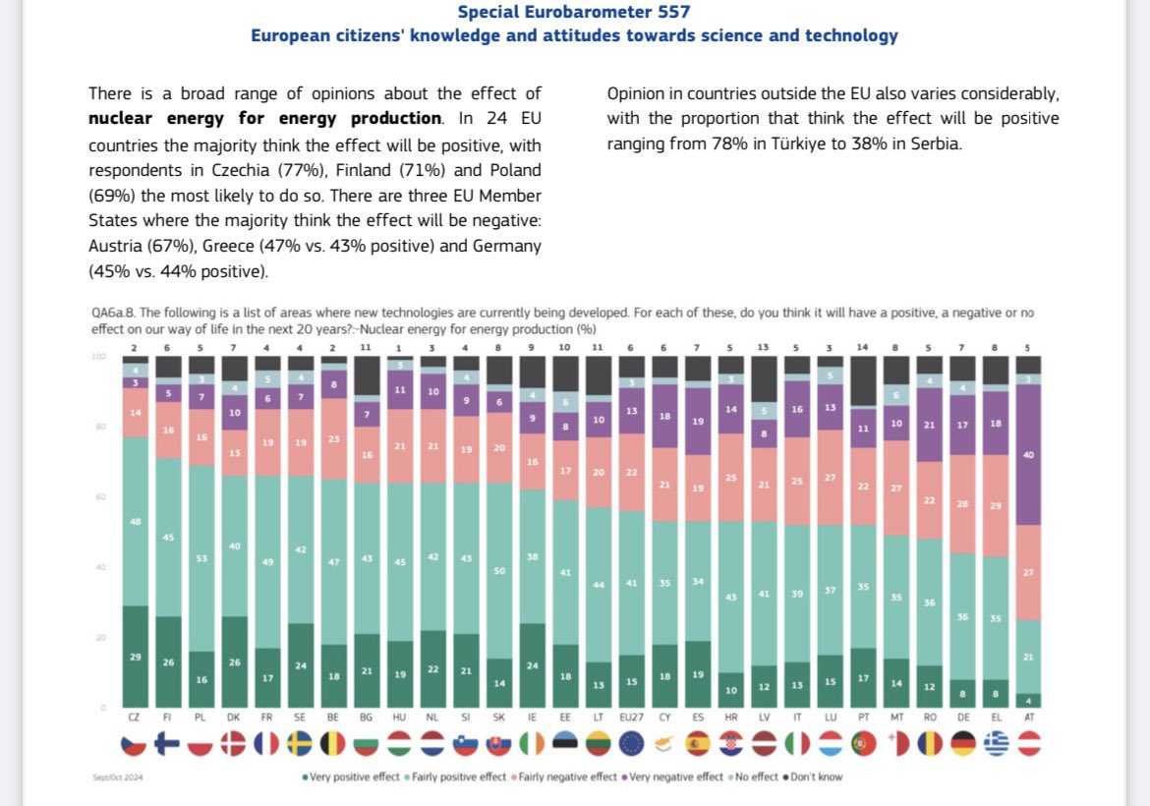Fig. 1. Eurobarometer: Data from February 2025[1]

1. Eurobarometer: Data from February 2025: https://europa.eu/eurobarometer/surveys/detail/3227